
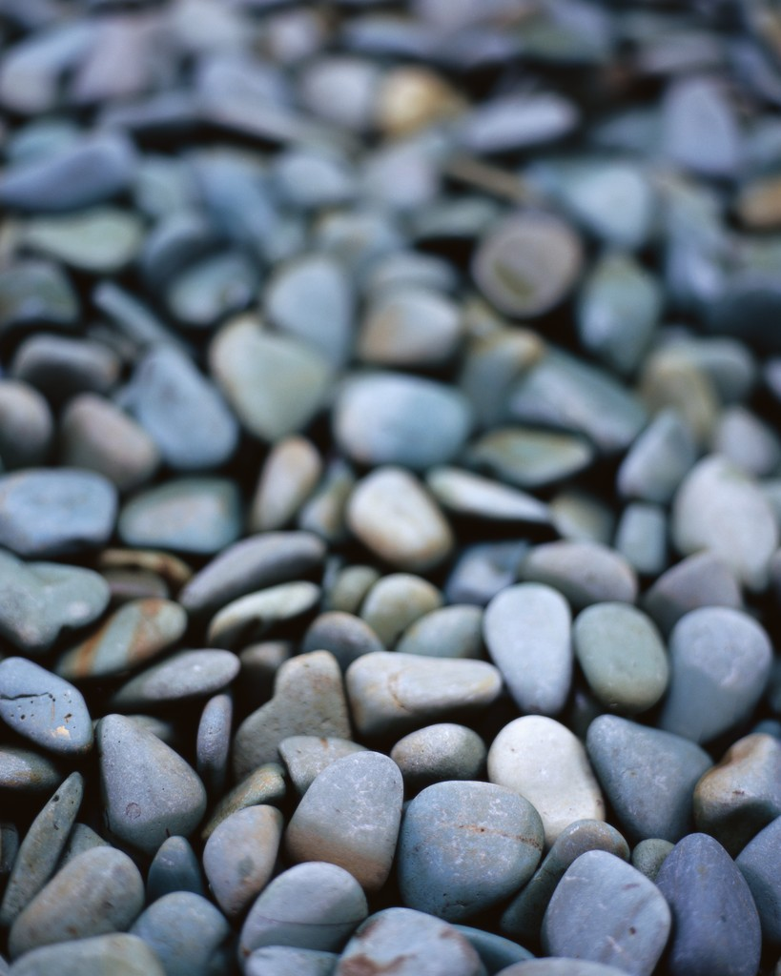
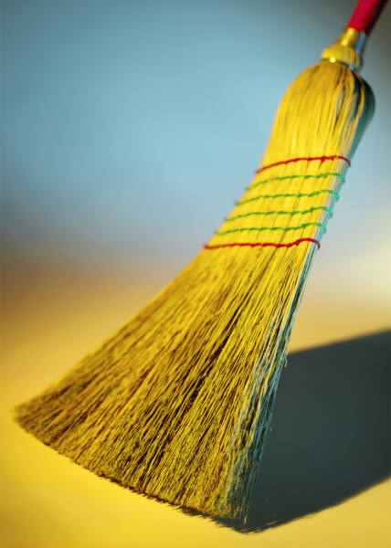
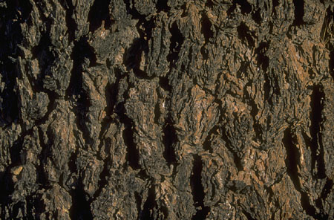
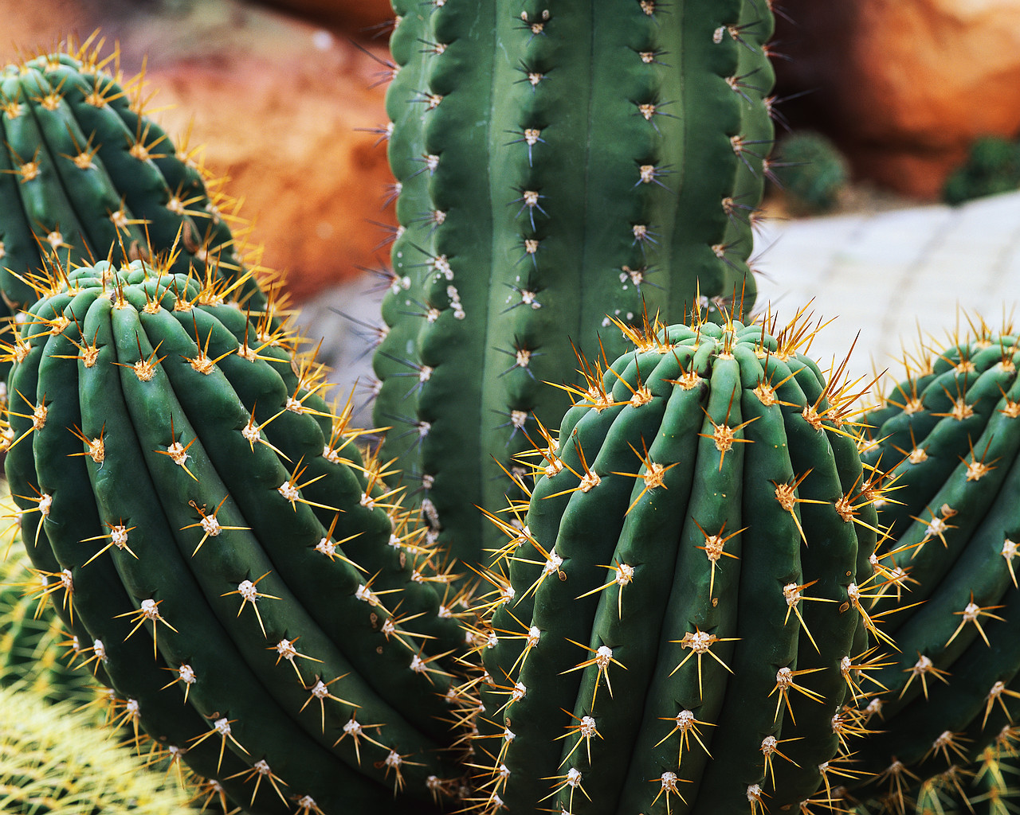

Copyright © 2008 The Source for Learning. Classroom copies permitted. All other rights reserved.
The sheet is part of Lessons for All on http://www.TeachersFirst.com

Copyright © 2008 The Source for Learning. Classroom copies permitted. All other rights reserved.
The sheet is part of Lessons for All on http://www.TeachersFirst.com

