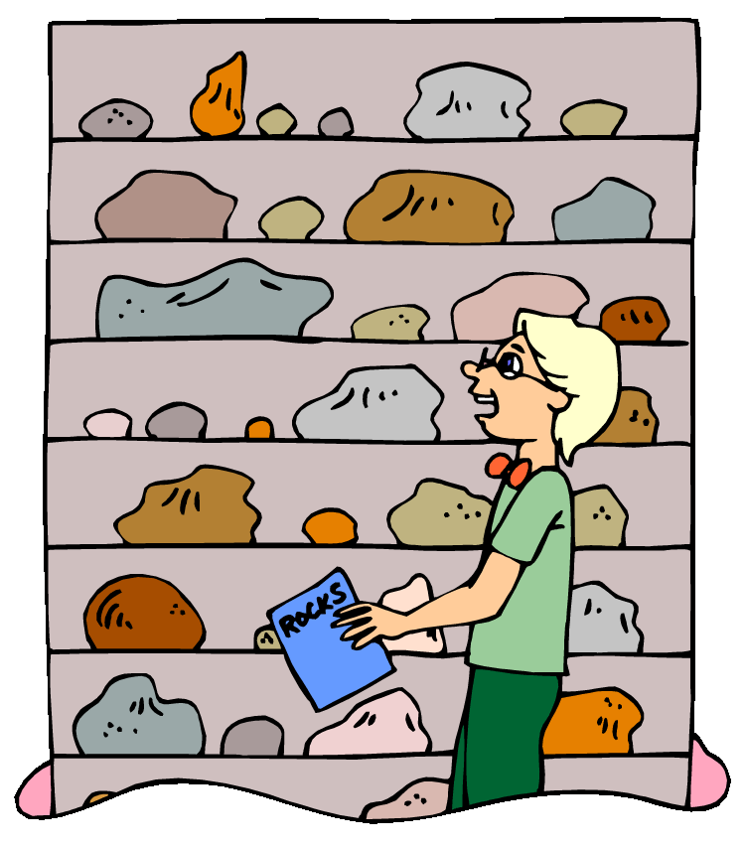
Name:

Choose the one you like best!
You have been asked to find information about THREE types of rocks:
igneous, metamorphic, and sedimentary.

You must choose the Web site that has the BEST information about these rocks.

Click on each of the Web site addresses below to visit the sites.
http://www.cotf.edu/ete/modules/msese/earthsysflr/rock.html
http://www.learner.org/interactives/rockcycle/
http://www.windows.ucar.edu/tour/link=/earth/geology/rocks_intro.html&edu=elem

1. Choose the ONE you like best, insert an asterisk next to it, and answer these questions about it:

2. What is the NAME of the site you’ve chosen? Click in the space below and type your answer:

3. Why do you think this is the best site? Click in the space below and type your answer:

4. What DIDN’T you like about the other sites? Click in the space below and type your answer:
After you have answered all of these questions and checked with your teacher, you may visit this video to learn more about the rock cycle. (YouTube video may be blocked in some schools). You can also try this Rock Cycle tour and game.

